**A PROJECT DOCUMENTATION**

**ON**

**WEB DEVELOPMENT ON THRIFT STORE**

FOR

**“TECHWIZ 3 COMPETITION”**

**BY**

**NIRAN MICHEAL**

**EMMANUEL MADUEKE**

**AKINLADE WOFE**

**DAVID ERIVONA**

**APTECH COMPUTER EDUCATION**

**MARYLAND LAGOS**

**ABSTRACT**

**PROBLEM STATEMENT**

People often discard clothing items when they are no longer in use. They buy clothing from stores, malls, online retail stores, or regular neighborhood stores and later, when these clothes overgrow their utility, they throw them away or dump them in bins. This has even happened in case of high cost of clothing. People who can afford expensive fashion typically do not like to repeat their outfit. They move on to buy newer items barley after using current items on two or three occasions.

In simple terms, shopping for thrift fashion is second hand purchases for fashionable clothing.

**PROBLEM SOLUTION**

The solution is a website titled **THRIFT FASHION STORE**. It should help individuals with online shopping for second hand fashionable garments at affordable prices. Using HTML5, CSS3, Bootstrap, JavaScript, jQuery, AngularJS combined with the server side JSON, We would like to develop a well responsive and visually appealing website to be used by individuals. The server side JSON, contains all the implementation related to setting up the database, creating session models for joining different user-interface (UI) pages, calculating the cost of clothing etc. It is responsible for taking information from the database and making it available to the UI by mapping the category or item ID to the respective IDs stored in the database. The client side is responsible for showing the entire user interface, containing the CSS, HTML, and JavaScript.

**FUNCTIONAL DESCRIPTION**

* **HOME PAGE:** It will display menus such as Products, About us, Contact us, Feedback, and so on. It will contain Products displayed with images and captions. The home page will accept user information with a greeting message.
* **PRODUCTS:** This will display the products customers can order online via **Thrift Fashion Store**. Products can be displayed through an image gallery and can have product information such as availability, stock, price, discount (if any), product description, and so on.
* **THE SEARCH:** This area should be able to find any product a customer would like to find with ease.
* **CHECKOUT**: This should show the shopping cart contents and total bill based on product price and quantity of products purchased.
* **ABOUT US AND CONTACT US**: This menu option should display Email id, address, and contact number of the organization who is developing the system. This acts like the Customer Care service, which is available 24/7 to the users in case of any query.

**SCOPE OF PROJECT**

This Web portal will be a responsive and visually appealing Website to be used by individuals. This portal will be designed to provide shopping process by considering the various problems faced by the customers.

**ACKNOWLEDGMENTS**

TABLE OF CONTENTS

ABSTRACT ................................................................................................................................... 2

ACKNOWLEDGEMENT..................................................................................................................3

CHAPTER 1. INTRODUCTION........................................................................................................ 5

1.1 Problem Statement.............................................................................................................. 5

1.2 Constraints.................................................................................................... 6

CHAPTER 2. Project Plan .............................................................................................................. 6

2.1Product Perspective ............................................................................................................... 7

2.1.1Task sheet........................................................................................................................... 7

CHAPTER 3. Requirement analysis ......................................................................................... 8

3.1 Purpose of project .......................................................................................................... 8

3.2 Scope of project.............................................................................................................. 8

3.3 Assumptions................................................................................................................... 8

3.4 user interface ............................................................................................................... 9

3.5 Hardware interface....................................................................................................... 9

3.5.1 hardware interface................................................................................................... 9

3.5.2 Software interface ................................................................................................... 10

3.5.1.2 Technologies used.................................................................................................. 10

3.6 Product function.......................................................................................................... 10

3.7 Functional Requirements .......................................................................................... 11

3.7.1 Non-Functional Requirements ............................................................................... 11

CHAPTER 4. Design Documment..................................................................................... 12

4.`1 Detailed scope.......................................................................................................... 12

4.1.1 Flowchart.............................................................................................................. 13

4.2 High level case diagrams ........................................................................................ 13

4.3 Development ........................................................................................................... 13

4.4 Web interface ........................................................................................................ 14

4.4.1 state chart Diagram ........................................................................................ 16

4.2 Sequence Diagram ............................................................................................ 17

**CHAPTER 1: INTRODUCTION**

A thrift or thrift store is a shop that sells used goods cheaply and gives its profit to charity. Thrifting has evolved from an economic necessity to manage your budget to a mainstream counterculture movement. More traditionally understood as shopping at a thrift store or flea market, thrift shopping has taken secondhand shopping online. This transition to secondhand shopping has experts projecting the secondhand market to double in the next five years to US$77 billion according to thred-UP.  About 33 million consumers bought secondhand apparel for the first time in 2020 during the pandemic, mostly through online shopping. Countries like Malaysia had their average online basket size grow by 24% as compared to the same period in 2019.

The pandemic has seen many fall into difficult financial times, making affordability the key selling point of online thrift stores. An emphasis on slow fashion points to more conscious considerations for secondhand clothes that are of good quality and able to last. Not only are the fashion pieces found in online thrift stores cheaper than a brand new design, buying quality thrift pieces equates to needing to buy fewer pieces of clothing over time. These long-term savings make thrift clothing compelling for many consumers.

* 1. **PROBLEM STATEMENT**

People often discard clothing items when they are no longer in use. They buy clothing from malls, online retail stores, or regular neighborhood stores and later, when these clothes outgrow their utility, they throw them away or dump them in bins. This has even happened in the case of high cost clothing. People who can afford expensive fashion typically do not like to repeat their outfits.

They move on to buy newer items barely after using current items on two or three occasions. The older ones are then just discarded. This causes burden on the planet because as the number of such discarded fashion (which is still in good condition, nevertheless) increases, the effort to dispose them also increases.

These days, recycling, sustainability, and reuse are not just buzzwords, but actionable behaviors to support a better planet. Instead of discarding clothes that are still in good condition, but no longer required by the original buyers, these clothes can be sold as thrift fashion or pre-used clothing. In simple terms, shopping for thrift fashion is second hand purchases for fashionable clothing.

**1.2 CONSTRAINTS**

The Web portal will not have any facility to store information on the server. Information can be fetched from JSON/TXT files and users can view the same being displayed.

**CHAPTER 2: PROJECT PLAN**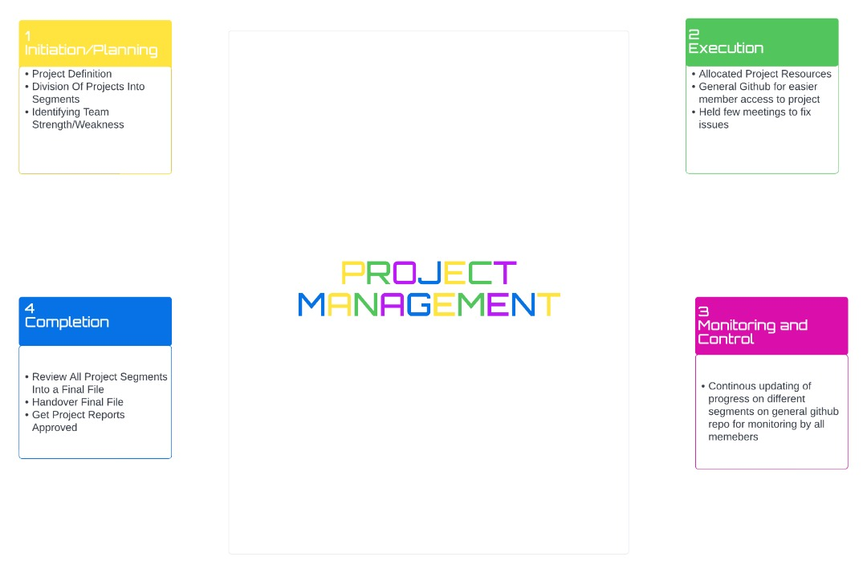

**2.1 PRODUCT PERSPECTIVE**

The Thrift fashion store website is a web-based system. It can be accessed using Microsoft Edge, Mozilla Firefox, and Google Chrome.

2.2 TASK SHEET

|  |  |  |  |  |
| --- | --- | --- | --- | --- |
| NO | TASK | DATE STARTED | DATE ENDING | PERSON ALLOCATED |
| 001 | Research on project related- technologies | 10/8/2022 | 12/8/2022 | Niran Micheal  Emmanuel Madueke |
| 002 | Acquisition of software | 10/8/2022 | 12/8/2022 | Niran Micheal |
| 003 | Design of interface | 11/8/2022 | 12/8/2022 | Akinlade Wofe |
| 004 | Coding | 11/8/2022 | 12/8/2022 | Niran Micheal  Akinlade Wofe |
| 005 | Routing | 12/8/2022 | 12/8/2022 | Akinlade Wofe |
| 006 | Testing | 12/8/2022 | 12/8/2022 | David Erivona |
| 007 | Deployment | 11/8/2022 | 12/8/2022 | Niran Micheal |
| 008 | Flowchart | 12/8/2022 | 12/8/2022 | David Erivona |
|  | Documentation | 11/8/2022 | 12/8/2022 | Emmanuel Madueke |

**CHAPTER 3: REQUIREMENT ANALYSIS**

**3.1 PURPOSE OF PROJECT**

Thrift Fashion Store provides an easy shopping facility for second hand clothing in excellent condition to the customers, wherein they can sit at one place and shop online anytime, anywhere 24/7.

The purpose of this project is to provide everyone who can’t get access to thrift stores, to easily carry a device and scout for readily available outfit on the web which will be delivered on time.

**3.2 SCOPE OF PROJECT**

This Web portal will be a responsive and visually appealing Website to be used by individuals. This portal will be designed to provide shopping process by considering the various problems faced by the customer.

**3.3 ASSUMPTIONS**

The assumptions are as follows:

* Users and the administrator are accustomed to the paper-based system and would require training to use the thrift fashion store website.
* We assume that system users adhere to the system’s minimum software and hardware requirements.

**3.4 USER INTERFACE(UI)**

* **User Interface**: Users are able to view the home page of the thrift store web page, browse the different categories, browse and add any number of items from any categories in the shopping cart, look for information about each product, delete the items in the shopping cart, save the cart for later viewing, check out or continue shopping after adding the item to the cart, and check out the items by completing the required information in the order form.
* **Admin Interface**: The administrator is able to view the users’ information that was entered during checkout in the database, can update the information, price, shipping costs of the items, add or remove items from the main display.

**3.5 HARDWARE INTERFACE**

The Thrift fashion web page shall provide minimum hardware requirements. The following hardware configurations are required for a PC using the online shopping-cart application:

* Intel Core i5 Processor or higher
* 8 GB RAM or above
* Color SVGA
* 500 GB Hard Disk space
* Mouse
* Keyboard

**3.5.1 SOFTWARE INTERFACE**

**3.5.1.1 SOFTWARE**

This section lists the requirements that are needed to run the system efficiently. The operating system needed for the system to run effectively, the interface to run the application, the driver for running web applications, the integrated development environment to develop the application are as follows:

* **Operating System**: Windows 7 and above or MAC OS
* **Web Brower**: Microsoft Edge, Mozilla Firefox, or Google Chrome
* **Drivers**: Intel Core i5 and above

**3.5.1.2 Technologies used**

This section lists the programming language used to develop the website both the frontend and database. Here are the languages as follows:

* **Frontend**: HTML5, CSS3, Bootstrap, JavaScript, jQuery, AngularJS, and XML
* **Data Store**: JSON/Text

**3.6 PRODUCT FUCTION**

The online Thrift store page would have the following basic functions:

* Display all the categories available for shopping on the system’s main page.
* Display all the items linked to each category listed on the main page.
* Allow the administrator to add new items to the existing list of available items.
* Allow users administrator to remove items.
* Allow the administrator to modify the price of each item.
* Allow the administrator to update the description about each item.

**3.7FUNCTIONAL REQUIREMENTS**

Following are the functional requirements of the portal:

* **Home Page:** It will display menus such as Products, About Us, Contact Us, Feedback, and so on. A few featured products displayed with images and captions will be displayed on the home page. The home page should accept first name from the user and display a personalized welcome message. At the top corner, the user's first name should be displayed for the entire duration that the portal is loaded.
* **Products:** This option will showcase the products one can order online via Thrift Fashion Store. Products can be displayed through an image gallery and can have product information such as availability, stock, price, discount (if any), product description, and so on.
* **Find Product:** Using this option, users can search for a specific product that they are looking out for/of their interest
* **Checkout:** This should show the shopping cart contents and total bill based on product price and quantity of products purchased. You need not implement payment functionality; just list the cart contents and compute the bill
* **About Us and Contact Us:** This menu option should display Email id, address, and contact number of the organization who is developing the system. This acts like the Customer Care service, which is available 24/7 to the users in case of any query.

**3.7.1 NON-FUNCTIONAL REQUIREMENTS**

There are several non-functional requirements that should be fulfilled by the system.

The system should be:

* **Safe to use:** The system should not result in any malicious downloads or unnecessary file downloads.
* **Accessible:** The system should have clear and legible fonts, user-interface elements, and navigation elements.
* **User-friendly:** The system should be easy to navigate with clear products/items and other elements and easy to understand.
* **Operability:** The system should operate in a reliably efficient manner.
* **Performance:** The system should demonstrate high value of performance through speed and throughput. In simple terms, the system should be fast to load and page redirection should be smooth.
* **Capacity:** The system should support large number of users.
* **Availability:** The system should be available 24/7 with minimum down time.
* **Compatibility:** The system should be compatible with latest browsers.

**CHAPTER 4: DESIGN DOCUMENT**

This chapter includes the detailed design used to build the online shopping-cart application. The system's design is used to create the functions and operations of the gathered requirements in detail.

These design elements describe the desired software features, in detail, including functional hierarchy diagrams, screen layouts, activity diagrams, and class diagrams. The intention of these diagrams is to describe the software in detail so that the system can develop the application with less additional design input. The system’s mock screen shots are shown later in this chapter.

**4.1 DETAILED SCOPE**

This product should be able to perform specific tasks

* Browse categories on the home page.
* Select a category and browse through clothing items.
* View more information about a clothing such as length and so on.
* Continue shopping or go to the checkout for the items.
* The user should be able to place an order on items.

4.1.1FLOWCHART

**4.2 HIGH LEVEL CASE DIAGRAMS**

The system’s use case shows the user a detailed view of the system and how the actors would interact with each other and with the system. The explanation for each use case is then provided below the system use case for the administrator (Figure 1) and the user (Figure 2), helping the user to understand who are the actors areas as well as giving the description for each use case along with its pre- and post-conditions that should be satisfied once the use case is implemented in the software.

Figure 1 demonstrates the use case of for an administrator where he or she has access to the application. The administrator can access the home page, select a category, or add/delete items to/from the cart.

HOME PAGE

SELECT CATEGORY

ADD ITEMS TO CART

VIEW CART

CONTINUE SHOPPING

CHECKOUT

VIEW DATABASE

Fig. 1. Online Shopping Cart Application System Use-Case Diagram: Admin.

Figure 2 demonstrates the use case for users where they have access to the online THRIFT FASHION STORE WEB PAGE. They can access the home page, select a category, add/delete items to/from the cart, view the shopping cart, and decide to either continue shopping or check out. They are required to go through the user-authentication form (login) which would only allow them to place an order for the items they selected.

HOME PAGE

**USER**

SELECT CATEGORY

ADD ITEMS TO CART

VIEW CART

CONTINUE SHOPPING

CHECKOUT

PLACE ORDER

4.3 Development

1. **Necessary resources** – 4PC’S and a classroom
2. **Number of developers** – 4
3. **Required skills**

* Knowledge about HTML, CSS, and JavaScript
* Knowledge about JSON
* Visual Studio Code

1. Hardware -

* Intel Core i5 Processor or higher
* 8 GB RAM or above
* Color SVGA
* 500 GB Hard Disk space
* Mouse
* Keyboard
  1. **WEB INTERFACE**
     1. **STATE CHART DIAGRAM**

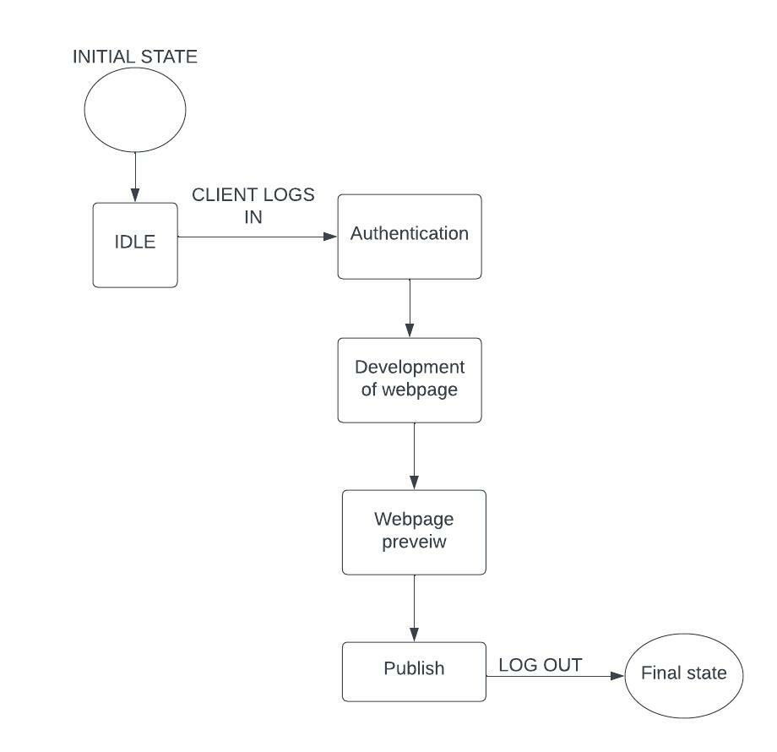

* + 1. **SEQUENCE DIAGRAM**

